This document has complete instructions about the installation process of the LAMP server in Ubuntu (18.04 or later)  server.

Install Apache, MySQL, PHP (LAMP) Stack on Ubuntu

1. Install Apache

sudo apt update && sudo apt install apache2

2. Configure Firewall

sudo ufw allow OpenSSH

sudo ufw allow in "Apache Full"

sudo ufw enable

sudo ufw status

3. Test Apache

sudo service apache2 status

4. Install MySQL

sudo apt update

&&sudo apt install mysql-server

sudo service mysql status

5. MySQL Security

sudomysql_secure_installation

-> ENTER | Y | Y | Y | Y

sudomysqladmin -p -u root version

6. Install PHP

sudo apt update&&sudo apt installphp libapache2-mod-php php-mysql

php -version

7. Installing phpMyAdmin

sudo apt update

sudo apt install phpmyadmin

sudo ln -s /etc/phpmyadmin/apache.conf /etc/apache2/conf-available/phpmyadmin.conf

sudo a2enconf phpmyadmin.conf

sudo service apache2 reload

8. Create MySQL User

Sudo mysql

CREATE USER'newuser'@'localhost'IDENTIFIED BY'password';

GRANT ALL PRIVILEGES ON* . * TO'newuser'@'localhost';

FLUSH PRIVILEGES;

exit

9. Secure PhpMyAdmin

sudo nano /etc/phpmyadmin/apache.conf

find this line and change the name:

Alias /**you_chosen_name** /usr/share/phpmyadmin

Old system

sudo nano /etc/apache2/conf-available/phpmyadmin.conf

Alias /your_url /usr/share/phpmyadmin

sudo service apache2 reload

10. Install ZIP/Unzip

apt-get update

apt-get install zip unzip

11. Enable .htaacess

sudo apt-get update

sudo a2enmod rewrite

sudo nano /etc/apache2/sites-enabled/000-default.conf

<Directory "/var/www/html"> no need

AllowOverrideAll   no need

</Directory>   no need

<VirtualHost *:80> no need

    <Directory /var/www/html>

        Options Indexes FollowSymLinks MultiViews

        AllowOverride All

        Require all granted

    </Directory>

</VirtualHost> no need

12. File Upload

After completing the server installation , now you can upload the project file to the server in “var/www/html“ directory. You can use filezila or other FTP applications to upload files to the server. Now unzip the file in “html” folder, make sure the “index.php” and “.htaacess” file in that directory.

Now go to phpmyadmin by “server_ip/phpmyadmin” this link. Create a database by following this screenshot.

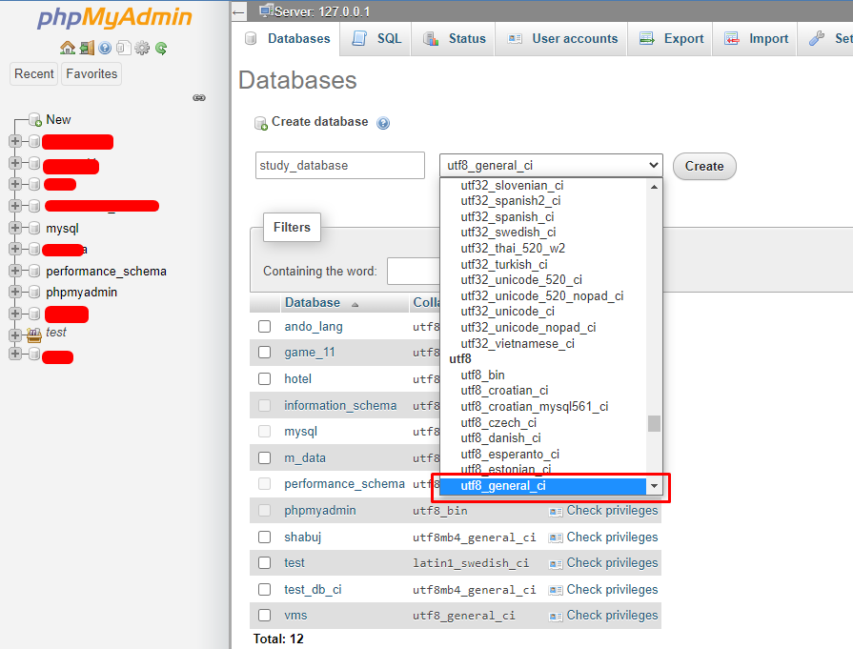

Now import the provided “install.sql” file in the database . To import go to the import tab then click on choose file button to upload file. Now click the go button to import the database.

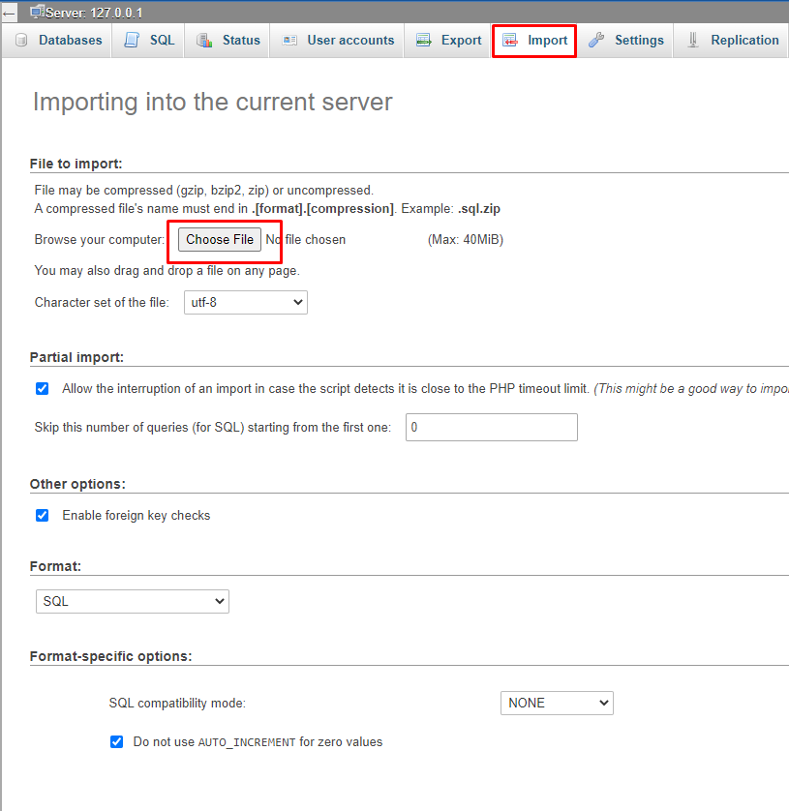

Now go to the browse tab to check if the database is imported successfully or not. If the database is okay, now you need to connect the database.

To Connect the database go to **app > Config > Database.php** file. Change the username , password and database name in this file.

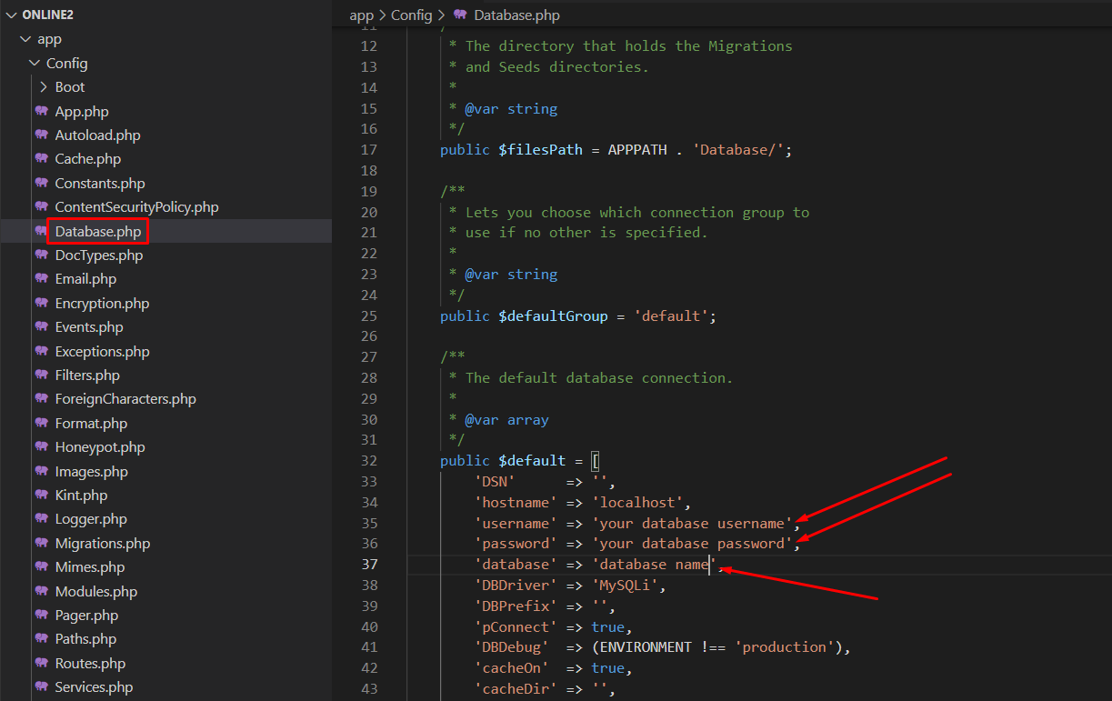

All set now you are good to go